Hart Publishing is very pleased to announce the publication of the new 3rd edition of A Casebook on Contract by Andrew Burrows and Networks as Connected Contracts by Gunther Teubner, Edited with an Introduction by Hugh Collins.

A Casebook on Contract New 3rd Edition
Andrew Burrows


Designed to be used in conjunction with a contract law textbook, this book covers the undergraduate contract law course in a series of clearly presented and carefully-structured chapters. The author provides an expert introduction to each topic and his succinct notes and questions seek to guide students to a proper understanding of the cases. The relevant statutes are also set out along with a principled analysis of them. In addition to cross-references to further discussion in the leading textbooks, an innovative feature is the summary of leading academic articles in each chapter. The book is designed not to overwhelm students by its length but covers all aspects of the law of contract most commonly found in the undergraduate curriculum.

Praise for the second edition:
'A well-written, accessible and well-balanced book which maintains the high quality of the previous edition.' Birke Häcker, Institut für Rechtsverleichung der LMU, Munich

PLEASE CLICK HERE TO VIEW THE TABLE OF CONTENTS

Andrew Burrows, MA, BCL, LLM (Harvard), QC (Hon), FBA, Barrister and Honorary Bencher of Middle Temple is Professor of the Law of England in the University of Oxford and a Fellow of All Souls College.

May 2011 892pp Pbk 9781849461634 £28.95 / €38
Discount Price for ODG members: £23 / €30
http://www.hartpub.co.uk/books/details.asp?isbn=9781849461634

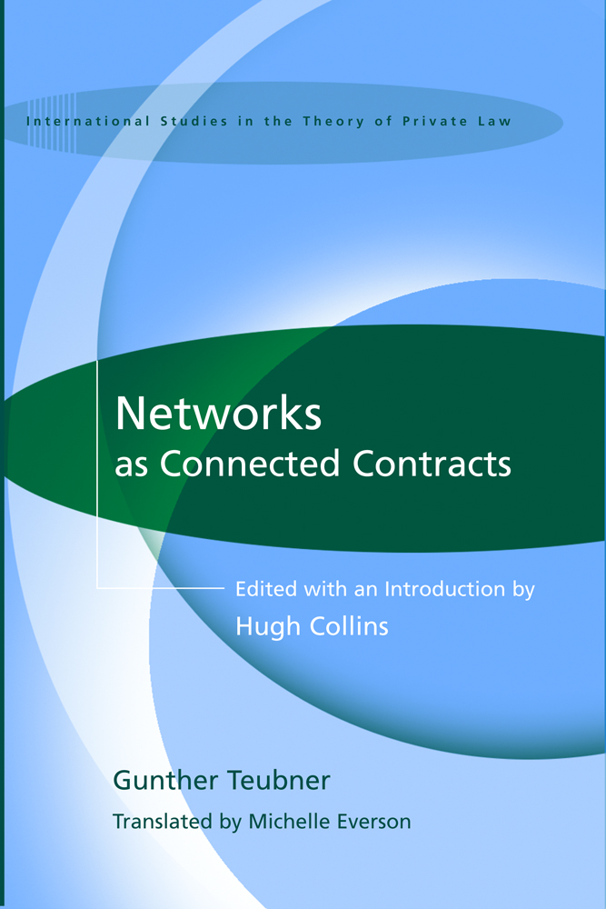
Networks as Connected Contracts
Edited with an Introduction by Hugh Collins
Gunther Teubner (translated by Michelle Everson)

Business networks consist of several independent businesses that enter into interrelated contracts, conferring on the parties many of the benefits of co-ordination achieved through vertical integration in a single firm, without creating a single integrated business such as a corporation or partnership. Retail franchises are one such example of a network, but the most common instance is a credit card transaction between a customer, retailer, and the issuer of the card. How should the law analyse this hybrid economic phenomenon? It is neither exactly a market relationship - because that overlooks the co-ordination, relational qualities and interdependence of the contracts - nor is it a type of business association or company, since it lacks a centralised co-ordinating authority that receives the residual profits.

This book is a translation of Gunther Teubner's classic work on networks, setting out his novel legal concept of 'connected contracts'. In it he explains how this concept addresses the problems posed by networks, such as the question whether the network as a whole can be held legally responsible for damage that it causes to third parties such as customers. A substantial introduction by Hugh Collins explains the analysis of networks in the context of German law and the systems theory from which Teubner approaches the topic. The introduction also explores how far the concept of connected contracts might assist in the common law world, including the UK and the USA, to address the same problems that arise in cases involving networks. As well as making a contribution to comparative law and legal theory, the book will be of interest to scholars interested in contract law, commercial law and the law of business associations.

PLEASE CLICK HERE TO VIEW THE TABLE OF CONTENTS

Hugh Collins is Professor of English Law at the London School of Economics.
Gunther Teubner is Professor of Law and Principal Investigator at the Cluster of Excellence "Formation of Normative Orders", Goethe University Frankfurt am Main and Distinguished Professor at the International University College, Torino.

May 2011 314pp Hbk 9781849461740 £50 / €65
Discount Price for ODG members: £40 / €52
http://www.hartpub.co.uk/books/details.asp?isbn=9781849461740

___________________________________________________________________________
As a member of the Obligations Discussion Group listserv Hart Publishing is delighted to offer you 20% discount.

Order Online
If you would like to order these titles you can do so through the Hart Publishing website (links above).

To receive the discount please mention ref: ‘ODG’ in the special instructions field. Please note that the discount will not be shown on your order but will be applied when your order is processed.

